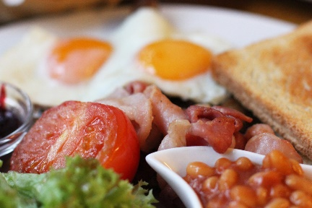
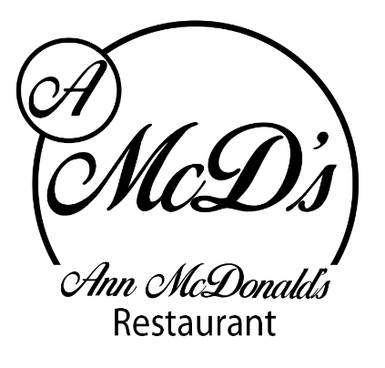
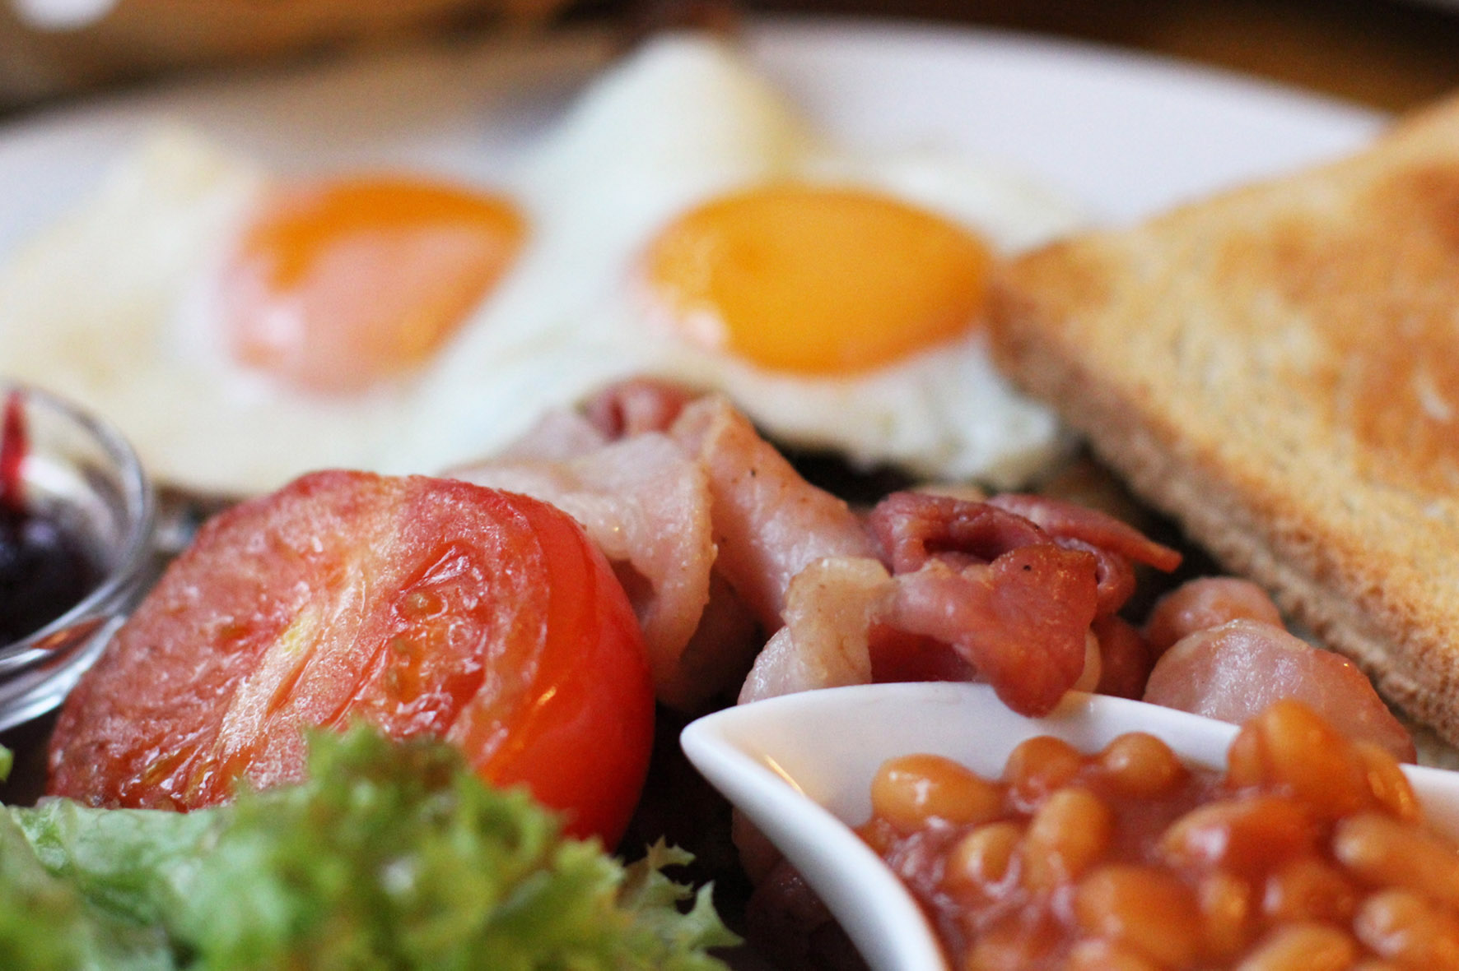Ann McDonald’s Café/Restaurant

This Photo by Unknown Author is licensed under CC BY-NC-ND
Breakfast Menu

Gluten free Granola, berry compote, Greek yogurt and raw honey €6.50

Overnight Oats with berry compote, Greek yogurt and raw honey €6.50

Ann’s freshly baked scone with Wexford home preserve and fresh cream €2.70

Selection of freshly baked pastries €

Traditional Full Farmhouse Breakfast: 2 craft butcher sausages, 2 O’Neills bacon, 2 craft puddings, local free-range egg, mushrooms, beans & hashbrown, toast, tea or coffee €9.90

Traditional Farmhouse small Breakfast: 1 craft butcher sausage, 1 O’Neills bacon, 1 craft pudding, local free-range egg, beans & hashbrown, toast, tea or coffee €7.50

Eggs Benedict €9.50
Crispy bacon and local free-range egg sitting on toasted sourdough bread, drizzled with hollandaise sauce

Brioche French Toast with fruit compote and Greek yogurt or crispy bacon and maple syrup €9.50

Smashed Avocado, crispy bacon and local free-range eggs on sourdough toast €9.50

Pancake stack with crispy bacon and maple Syrup €9.00

Pancake stack with fruit compote and Greek yogurt

Pancake stack with Nutella and chocolate drops

Smashed Avocado with roasted tomatoes and lightly spiced beans on sourdough toast €9.50

Berry Breakfast Smoothie €4.95
Banana, mixed berry, apple juice and honey

Green Breakfast Smoothie €4.95
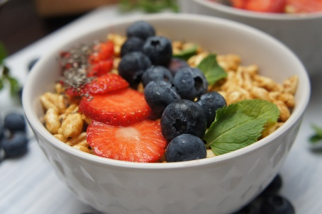
Spinach, broccoli, celery, banana and honey

While living on Sloeberry Farm in Inistioge, we appreciate our beautiful countryside and food producers.
Ann McDonald’s Café promise beautiful food, made with the best local produce. We serve our food in an informal environment with good vibes to start your day.
To live a full life, you have to fill your stomach first….

