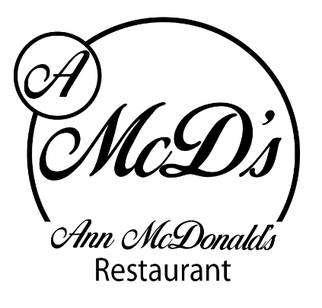
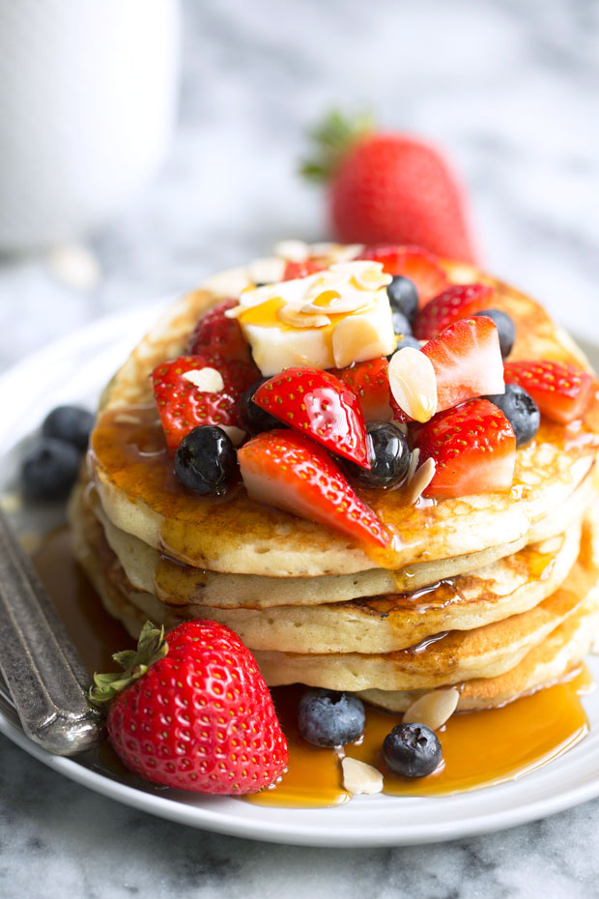Ann McDonald’s Café/Restaurant

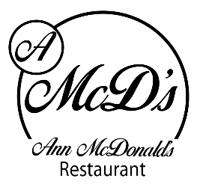
Pancake Menu

Classic Pancakes: Golden Pancakes drizzles with Lemon and Sprinkled with Sugar (1, 2, 4,) €6.50

Chocolate Marble Pancakes: Golden Pancakes filled with Chocolate Chips, Whipped Cream and drizzled in Chocolate Sauce (1, 2, 4, 7, 8) €7.50
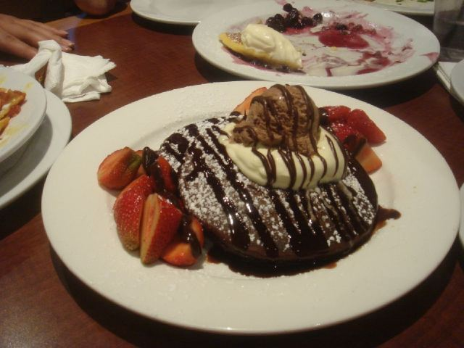
Banoffee Pancakes: Golden Pancakes with bananas and cream drizzled in Caramel Syrup (1, 2, 4) €7.50
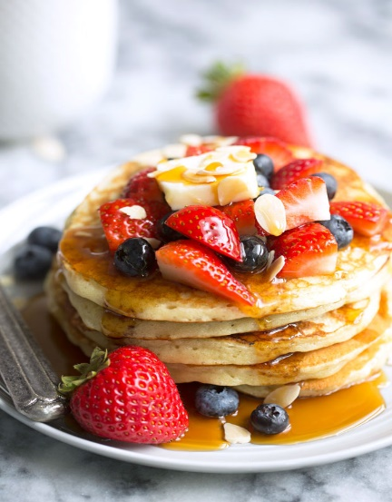
Fresh N Fruity Pancakes: Golden Pancakes with Assorted Fresh Selection of Fruits and Whipped Cream (1, 2, 4) €7.50

American Classic: Golden Pancakes with Crispy Bacon and Maple Syrup (1, 2, 4) €8.50

Kids Portion Available From €4.50

Make your own Pancakes: Extra filling €1.00
Allergens: 1. Milk, 2. Cereals, 3. Crustaceans, 4. Eggs, 5. Fish, 6. Peanuts, 7. Soybeans, 8. Nuts, 9. Celery, 10. Mustard, 11. Sesame Seeds, 12. Sulphur dioxide & Sulphites, 13. Lupins, 14. Molluscs

