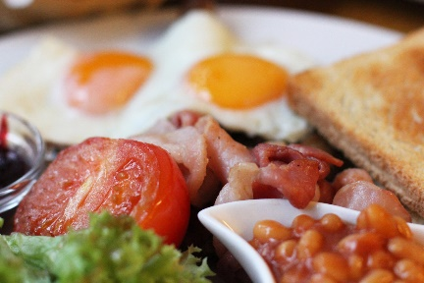
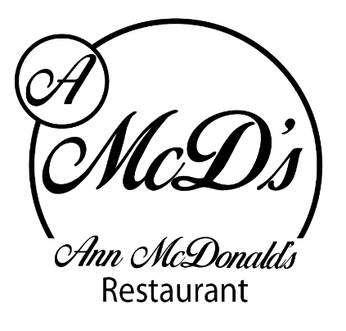
Ann McDonald’s Café/Restaurant
Breakfast Menu
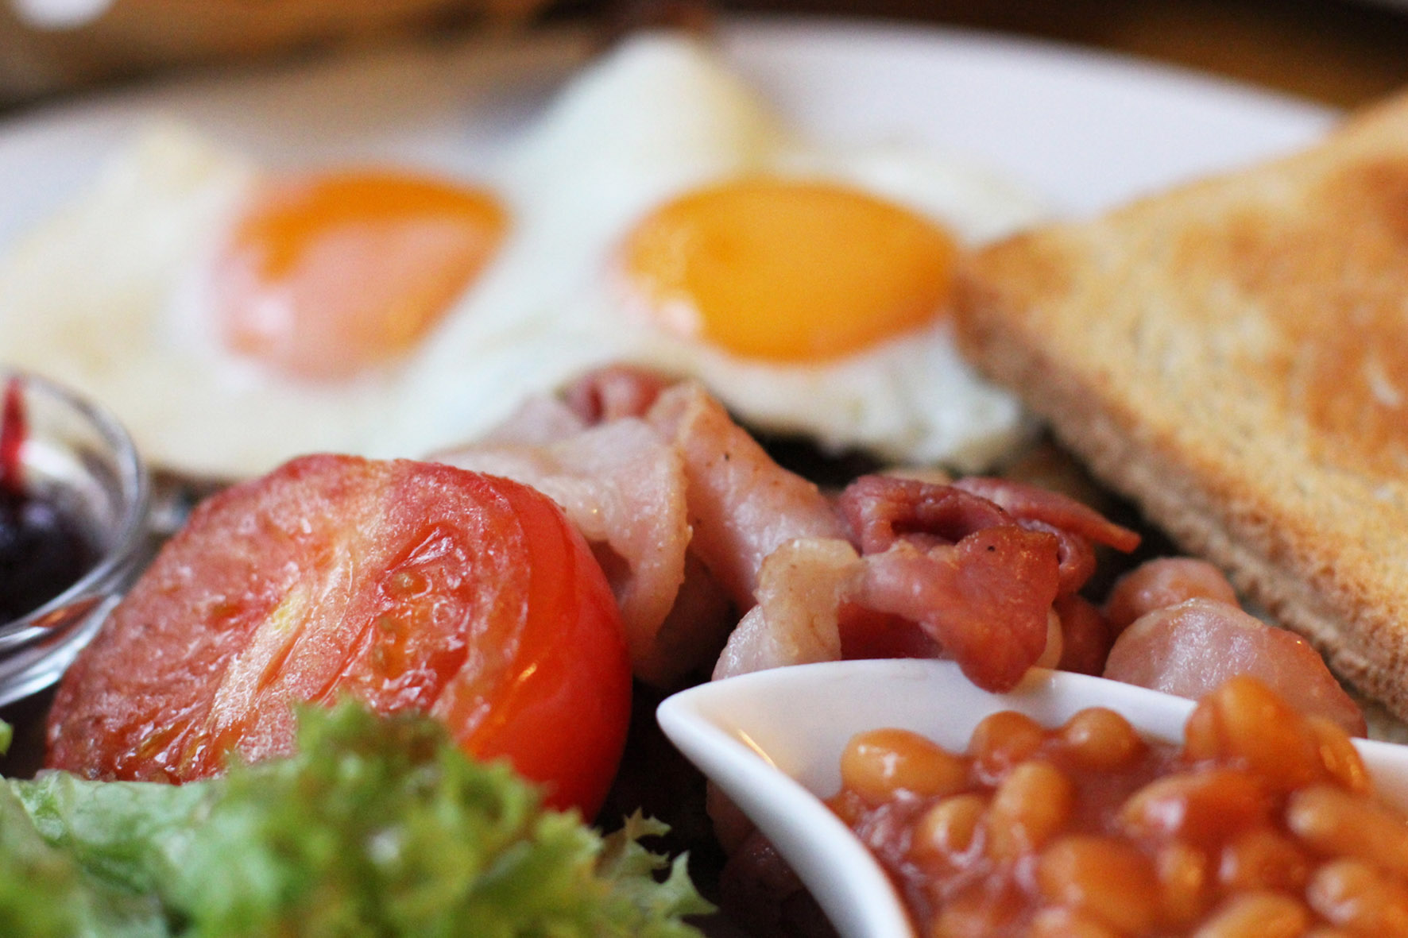

This Photo by Unknown Author is licensed under CC BY-NC-ND
Porridge with berry compote, Greek yogurt and raw honey 1,2 €6.95

Traditional Full Farmhouse Breakfast: 2 craft butcher sausages, 2 O’Neill’s bacon, 2 craft puddings, local free-range egg, mushrooms, beans & hashbrown, toast, tea or coffee (Americano) 1, 4, €9.90

Traditional Farmhouse small Breakfast: 1 craft butcher sausage, 1 O’Neill’s bacon, 1 craft pudding, local free-range egg, 1 craft pudding, beans & hashbrown, toast, tea or coffee (Americano) 1, 4 €7.95

Scrambled Free-range Eggs with O’Neill’s dry cure Bacon 1, 4 €8.50

Slimmer’s Choice: Poached Eggs, grilled tomato, mushrooms and 2 grilled O’Neill’s bacon 4, 1 €9.90
Homemade brown bread, tea or coffee (Americano)

Vegetarian Breakfast: 2 local free-range eggs, baked beans, mushrooms, grilled tomato and sauté potatoes, toast, tea or coffee (Americano) 1,4 €9.50

All breakfasts served with Tea/Coffee & Toast, upgrade to herbal teas 50c, or premium coffee €1.00

Breakfast Burrito: Scrambled free-range eggs, crumbled sausage, red pepper, tomato, red onion and mixed cheese in a wheat flour tortilla 1, 2, 4 €7.95

Smashed Avocado, crispy bacon and local free-range poached eggs on sourdough toast 4, 1 €9.50

Pancake stack with crispy bacon and maple Syrup 1, 2, 4 €8.50

Pancake stack with fruit compote and Greek yogurt 1, 2, 4 €7.50

Berry Breakfast Smoothie €5.50
Banana, mixed berry, apple juice and yogurt 2

Oatie Smoothie (Vegan and Dairy Free) €7.00
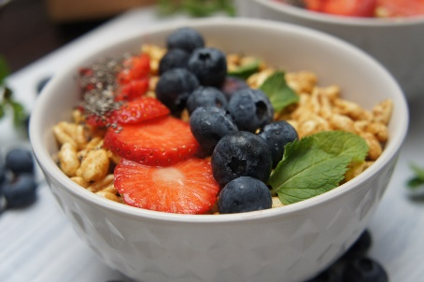
Blueberries, Banana, Raspberries and Oat Milk

Ann’s freshly baked scone with Wexford home preserve and fresh cream 1, 2, 4 €3.00

Freshly Squeezed Orange Juice €3.95

Food Allergens:
1; Cereals containing gluten 2: Milk 3: Crustaceans 4: Eggs 5: Fish 6: Peanuts 7: Soybean 8: Nuts 9: Celery 10: Mustard 11: Sesame Seeds
12: Sulphur dioxide and Sulphites 13: Lupins 14: Molluscs

